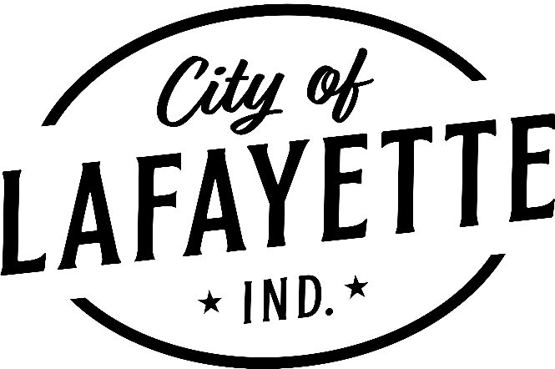

News Alert

Patty Payne
Communications Manager
City of Lafayette, Indiana
(765) 807-1006
ppayne@lafayette.in.gov
FOR IMMEDIATE RELEASE
May 2, 2025

Norfolk Southern to Begin Maintenance on Key Lafayette Railroad Crossings

LAFAYETTE, INDIANA – May 2, 2025 – The City of Lafayette has received official notice from Norfolk Southern that long-anticipated maintenance will soon begin on several heavily traveled railroad crossings throughout the city. These improvements aim to enhance ride quality and overall safety for motorists.

Three high-priority crossings in Lafayette are scheduled for repair and will require temporary road closures at crossings on:
- 9th Street near Armstrong Park: closed May 19–23
- Concord Road between Daugherty Drive and Olympia Drive: closed May 27–30
- South 18th Street between Brady Lane and Normandy Drive: closed June 2–4

Norfolk Southern will also be completing repairs at County Road 900 South in Dayton and Wyandotte Street in Mulberry, helping improve regional transportation routes beyond the Lafayette city limits.

Mayor Tony Roswarski expressed appreciation for the progress, stating, “These crossings have been a consistent concern for drivers, and we’re pleased to see Norfolk Southern taking meaningful steps to address them. City officials have elevated these concerns for several years, and it’s encouraging to see that feedback reflected in upcoming repairs. We thank the community for their patience during these short closures and look forward to smoother, safer roads ahead.”

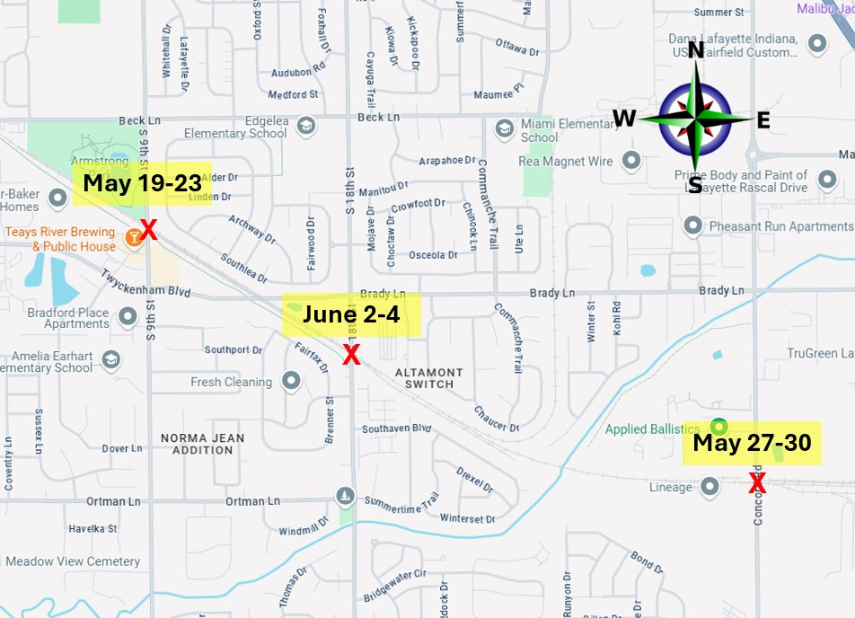

For more information, please contact:
Jeromy Grenard
City Engineer/Public Works Director
(765) 807-1050
jgrenard@lafayette.in.gov

###

